# Describing Relationships

Does drinking coffee impact one’s amount of sleep? A group of people were surveyed about their coffee drinking and sleeping habits.

| Daily Cups of Coffee | Sleep (minutes) |
| --- | --- |
| 3 | 400 |
| 0 | 480 |
| 8 | 310 |
| 1 | 300 |
| 1 | 390 |
| 2 | 360 |
| 1 | 410 |
| 0 | 500 |
| 2 | 390 |
| 1 | 480 |
| 3 | 360 |
| 4 | 430 |
| 0 | 450 |
| 5 | 240 |
| 1 | 420 |
| 2 | 380 |
| 1 | 480 |

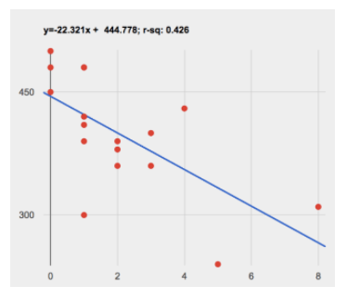

Describe the relationship between coffee intake and minutes of sleep shown in the data above.

*These materials were developed partly through support of the National Science Foundation, (awards 1042210, 1535276, 1648684, and 1738598).  Bootstrap by the* [*Bootstrap Community*](https://bootstrapworld.org/community/index.shtml) *is licensed under a* [*Creative Commons 4.0 Unported License*](https://creativecommons.org/licenses/by-nc-nd/4.0/)*. This license does not grant permission to run training or professional development. Offering training or professional development with materials substantially derived from Bootstrap must be approved in writing by a Bootstrap Director. Permissions beyond the scope of this license, such as to run training, may be available by contacting* [*contact@BootstrapWorld.org*](https://www.bootstrapworld.org/materials/spring2021/en-us/courses/reactive/mailto:contact@BootstrapWorld.org)*.*

Last updated 2021-12-09 14:35:49 -0500